The 7th International Conference on Formal Linguistics
Transportation & Accommodation

I. Transportation

- From Beijing Capital International Airport to Nankai University (Balitai Campus, 94 Weijin Road)

1）By airport shuttle bus to Tianjin

Terminal 2: take the shuttle bus at gate 15 on the 1st floor
Terminal 3: take the shuttle bus at gate 3 on the 1st floor
Departure Time: 7: 00 - 23: 00 (The bus runs every one hour before 9:00AM and every 30 minutes after 9: 00AM.)
Duration: 2 hours 45 mins
Price: RMB82
Destination: Tianhuan Passenger Station in Tianjin

2）From Tianjin Tianhuan Passenger Station to Nankai University
By Taxi:
about RMB15（to the east gate of Nankai University）

- From Tianjin Binhai International Airport to Nankai University (Balitai Campus, 94 Weijin Road)

By taxi:
about RMB75 (about RMB100 for high-emission taxi) to the east gate of Nankai University

By subway:
- Line 2: from Tianjin Binhai International Airport Station to Tianjin Railway Station, then transfer within the station to
- Line 3: from Tianjin Railway Station to Tianta Station
- Walk north along Weijin South Road to the east gate of Nankai University, about 15mins
- From Tianjin Railway Station to Nankai University (Balitai Campus, 94 Weijin Road)

By taxi:
about RMB25, to the east gate of Nankai University

By subway:
- Line 3: from Tianjin Railway Station to Tianta Station
- Walk north along Weijin South Road to the east gate of Nankai University, about 15mins

- From Tianjin South Railway Station to Nankai University (Balitai Campus, 94 Weijin Road)

By taxi:
about RMB40, to the east gate of Nankai University

By subway:
1) Line 3: from Tianjin South Railway Station to Tianta Station
2) Walk north along Weijin South Road to the east gate of Nankai University, about 15mins

- From Tianjin West Railway Station to Nankai University (Balitai Campus, 94 Weijin Road)

Taxi:
about RMB20, to the east gate of Nankai University

By bus:
1) No.161 (or No.168) from Tianjin West Bus Station to Balitai Bus Station
2) Walk south along Weijin South Road to the east gate of Nankai University, about 2mins

Directions from the east gate of Nankai University to Mingzhuyuan Hotel (the conference registration site)

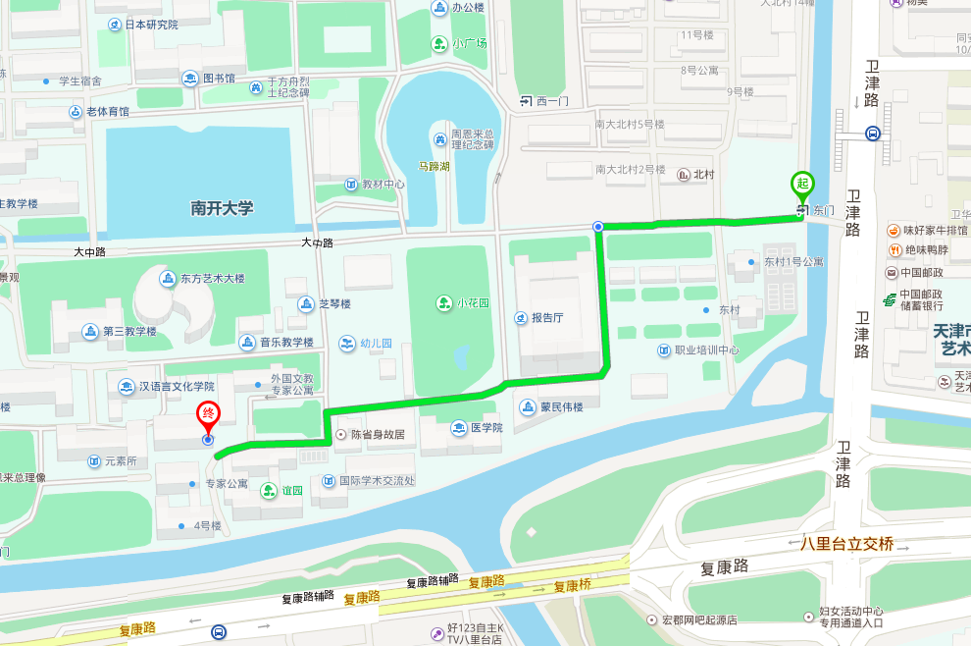

II. Accommodation
1. We have reserved 105 hotel rooms on campus, including 60 rooms (with two beds) at Mingzhuyuan Hotel, 20 rooms (with two beds) and 5 rooms (with one bed) at Nankai-Aichi Guesthouse, and 20 rooms (with two beds) at Yiyuan Hotel (No.4 Building). But you can choose to stay off campus.
2. If you would like to share a room, please notify the hotel reception desk after registration.

Hotel | Type | Price | Facilities
Mingzhuyuan | With two beds | RMB 320 (with breakfast) | With internet access and cable TV
Nankai-Aichi Guesthouse | With two beds | RMB 298 (with breakfast) | With internet access and cable TV
Nankai-Aichi Guesthouse | With one bed | RMB 288 (with breakfast) | With internet access and cable TV
Yiyuan  (No.4 Building) | With two beds | RMB 180 (with breakfast) | With internet access and cable TV
III. Nearby Restaurants
We provide lunch and dinner during the conference on Dec.3-4. But if you would like to try other cuisines, the following restaurants are some good options nearby.
Restaurant | Cuisine | Average cost/person | Address | Telephone
Bogeda | Muslim | RMB 35 | No.5 Building, Jiatai Garden, Changshi Road, Nankai District | 022-23620152
Baduan Xiaochu | Mixture | RMB 80 | Zhongtian Building, No. 3 Fukang Road, Nankai District | 022-23352756
Coffee Legend  (Baidi Road) | Western-style | RMB 80 | Post-doctoral Apartment, Baidi Road, Nankai District | 022-87896000
Fridays | Western-style | RMB 150 | Teda International Club, No.7 Fukang Road, Nankai District | 022-58695555
AYingbao  (Daxue Road) | Shanghai | RMB 55 | Kemao Building, Xuefu Street, Nankai District | 022-87458358
Siam | Thai | RMB 100 | No.2 Shuishangbei Road, Nankai District | 022-23351878

